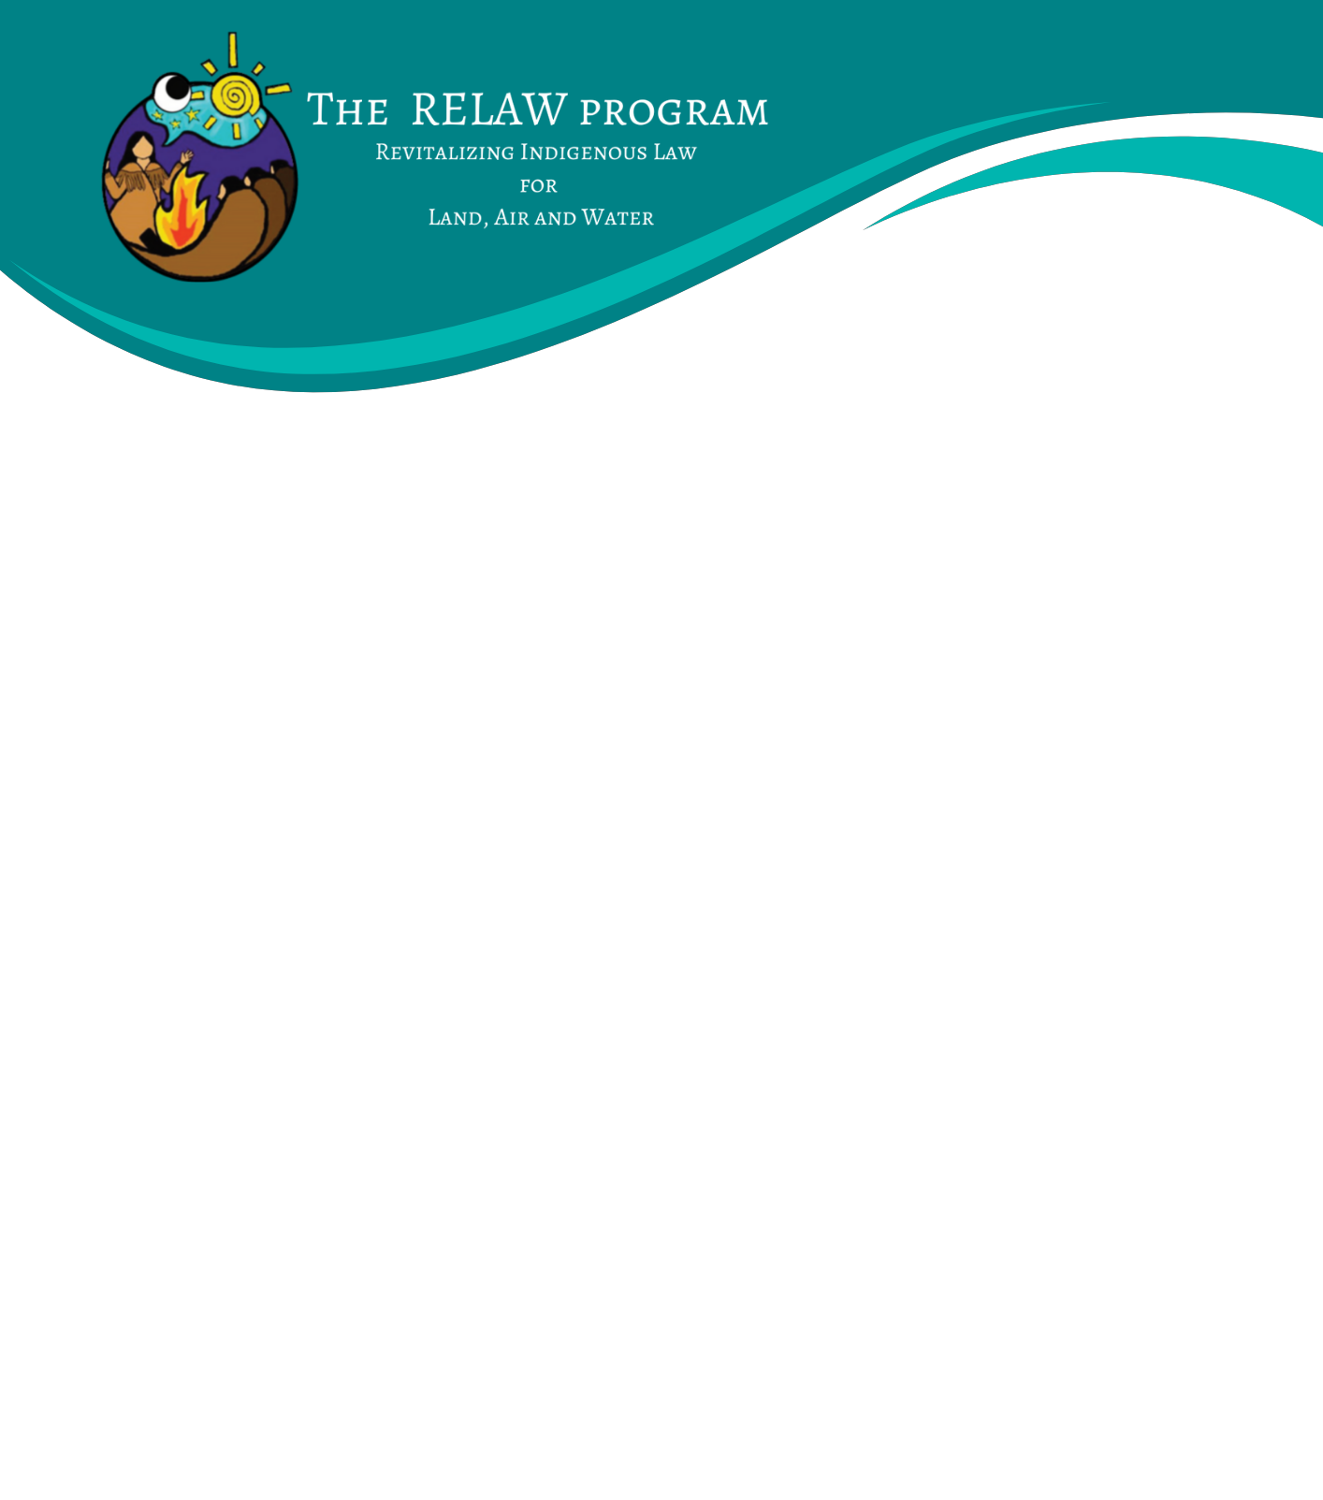

## RELAW Co-learning Program’s Cohort of 2025-26

## EXPRESSION OF INTEREST

We are currently accepting Expressions of Interest to our RELAW Co-learning Program 2025-26 from individuals who wish to learn alongside other participants in a knowledge exchange on various approaches and methods of researching, applying and enforcing Indigenous laws. The RELAW Co-learning Program is expected to run from November 2025 – June 2026 with three retreats in British Columbia (two in-person, one online):

1. RELAW Retreat 1: Indigenous Law in Story – November 24-27, 2025 – Manning Park Resort on the unceded homelands of the Stó:lō, Syilx, and Similkameen First Nations
2. RELAW Retreat 2: Indigenous Law in Dialogue – February 18-20, 2026 – Online 1/2 days
3. RELAW Retreat 3: Indigenous Law in Action – June 1-4, 2026 – Loon Lake Lodge & Retreat Centre, located in Katzie “q̓ic̓əy̓ – …land of the moss” territory

For more details visit:<https://www.wcel.org/background-relaw-co-learning-program>

Indigenous nations or organizations may nominate community members, employees or others with an ongoing, close relationship to the community, to participate in the RELAW Co-learning Program.

Expenses covered for the RELAW co-learning retreats include materials, program content, accommodations and meals. Travel to and from the retreat location is the responsibility of the nominating nation or individual co-learner. Stipends may be available to assist with travel costs if your nation (or the nation you work for) is not able to cover this cost.

To apply, please complete the form below and submit to[admin@wcel.org](mailto:admin@wcel.org)with subject line “RELAW Co-learning Program 2025-26”. Space is limited and first consideration will be given to **applications received by August 20, 2025.**

*The RELAW Co-learning Program is intended to bring together a cohort of individuals who are working in community or in their nation to revitalize, apply and enforce their laws. Final decisions on the cohort will be in late August 2025. The cohort will be ~30 participants (including RELAW team and facilitator(s)). If you are accepted, we will e-introduce you all to each other once the cohort is selected.*

*We strive to create a safe environment for our co-learners. We will call your references, and if you are accepted, we will ask you to agree to our “RELAW protocols” that call for respect, listening and sharing space with others.*

Name:

Your nation/community, if known:

Position & Contact information (email and phone):

1. Please tell us why you’re interested in participating in the RELAW co-learning program and how your participation will help contribute to revitalization of Indigenous law for your nation/community (minimum one paragraph).
2. Please describe themes or topics you are most interested in learning about, if any (i.e., researching Indigenous law and stories, climate change, how to host inclusive good gatherings, connections with elders, LGBTQ2S+, youth, project management and work-planning, communications such as press release drafting, preparing leadership to make a decision, etc.).
3. Is there support you need to make the in-person retreats accessible to you?

* *For example, family participation, travel subsidy and other requests or needs related to audio, visuals, food, wheelchair and other physical/mobility-related access, bathrooms, scent & chemicals, lighting or sound, time, language, quiet space, spiritual/religious time/space, transportation or other identity-related considerations.*

4) If you are interested in participating and it is not possible for your nation to nominate you, please offer a brief explanation.

__________________________________________________________

Applicant signature

Reference name from your nation or the nation/community you are working with to confirm nomination:

________________________________________ __________________________________________

Name Role/Relationship

________________________________________ __________________________________________

Phone Number Email

*We will reach out to them by email and/or phone in late August 2025*

**If you have any questions, please contact:** Katlia Lafferty, RELAW Program Manager at [klafferty@wcel.org](mailto:klafferty@wcel.org)